**PIP2001 Capstone Project**

**Review-0**

# Customer Support Chat Bot With ML

**Batch Number: 168**

|  |  |
| --- | --- |
| STUDENT ROLL NO | STUDENT NAME |
| 20211CSE0354 | NAVEEN KUMAR M |
| 20211CSE0369 | MAHMADKAIP R SHIKKALAGAR |
| 20211CSE0383 | MOHAN S G |
| 20221LCS0013 | MADHU K |

**Name of the Program: CSE**

**Name of the HoD: Dr.Asif Mohammed H.B**

**Under the Supervision of,**

**Mr Asad Mohammed Khan**

**Professor / Associate Professor / Assistant Professor School of Computer Science and Engineering Presidency University**

**Name of the Program Project Coordinator: Mr. Amarnath J.L & Dr. Jayanthi. K.**

**Name of the School Project Coordinators: Dr. Sampath A K / Dr. Abdul Khadar A / Mr. Md Ziaur Rahman**

* Problem Statement
* Github Link
* Analysis of Problem Statement
* Timeline of the Project
* References

Organization:

Category (Hardware / Software / Both) : Software

Problem Description: The organization aims to enhance its customer support system by developing a machine learning-powered chatbot that can handle customer queries in real-time. The chatbot should understand natural language, categorize inquiries, and provide accurate, relevant responses. It should also be able to escalate issues to human agents when necessary, ensuring a seamless transition.

Difficulty Level: Medium

The Github link provided should have public access permission.

**Github Link**

Technology Stack Components:

1. React.js
2. Node.js
3. spaCy
4. Scikit-learn
5. MongoDB

Software and Hardware Requirements:

1. Operating System
2. Programming Languages
3. Libraries and Frameworks
4. Database
5. Development Tools

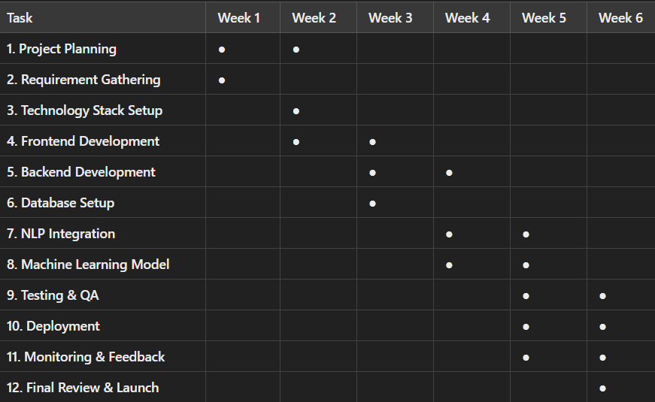

* A. Kumar and P. Gupta, "Chatbot for Customer Support System Using AI and ML," *International Journal of Advanced Research in Computer Science*, vol. 9, no. 3, pp. 25-30, 2019.
* J. Smith, "Natural Language Processing Techniques in Chatbots: A Comprehensive Survey," *Journal of Artificial Intelligence Research*, vol. 45, no. 2, pp. 112-120, May 2020.
* S. Zhang and Y. Wang, "Improving Chatbot Interactions with Machine Learning," in *Proceedings of the 11th IEEE International Conference on AI and ML Applications*, 2021, pp. 45-50.
* L. Davis, "An Overview of Machine Learning Algorithms for Chatbots," *IEEE Access*, vol. 7, pp. 123-

140, 2020.

THANK YOU